

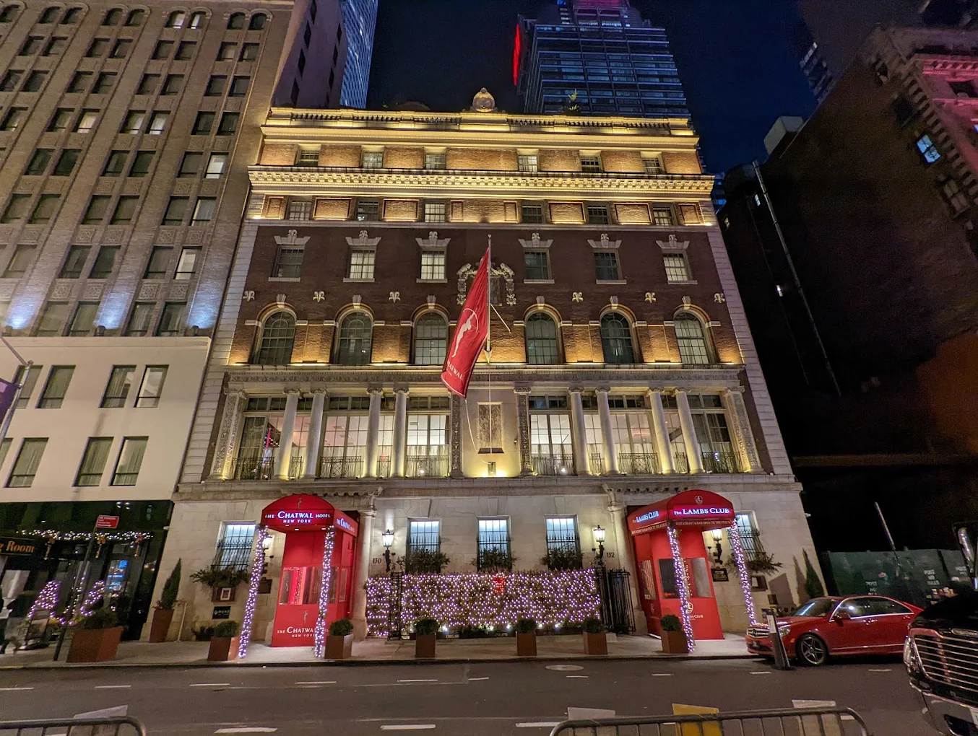

**THE CHATWAL HOTEL,**

**NEW YORK, NEW YORK**

**Feb 3rd 2026**

**KICK OFF**



A call or site meeting between the stake holders and Higney International will establish a general scope of work, budget and timeline. This serves as an introduction to all the team members and any consultants, including the owner's representative, property management, the procurement agent, project manager, contractor and any special consultants. The project manager will establish a regularly scheduled meeting and a project timeline. This process and approval phase should take approximately **two (2) weeks**.

**CONCEPT & SCHEMATIC DESIGN**

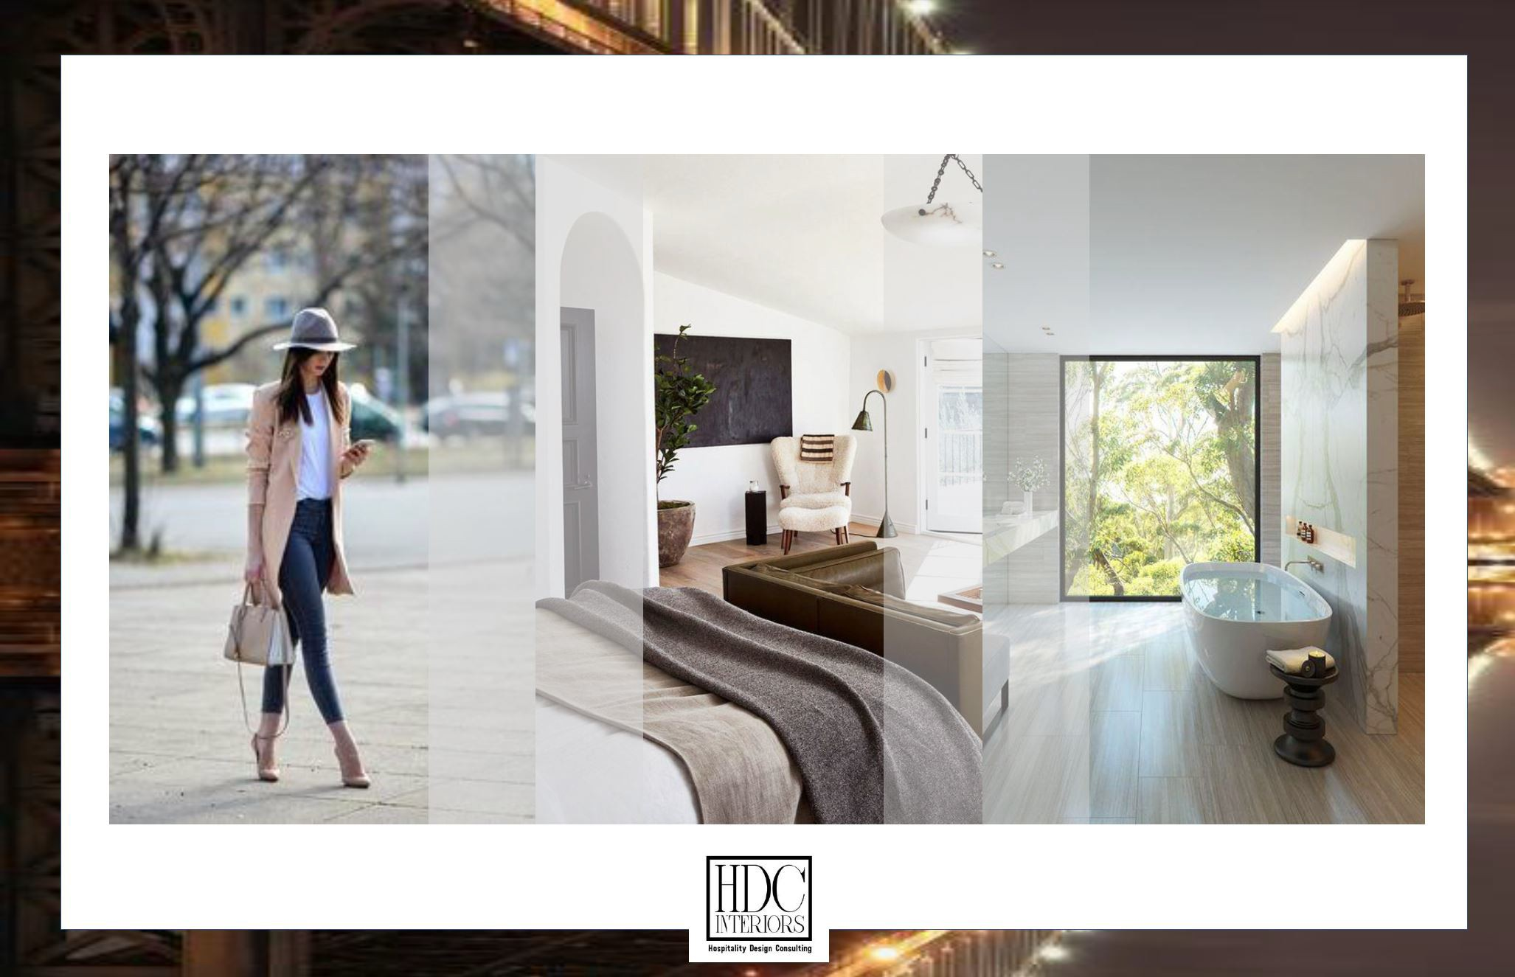

This phase includes the initial presentation to the stakeholders and introduces the Design Narrative, which outlines key design decisions and overall concept.

Supporting materials may include electronic mood boards and examples of furnishing styles. This step is essential in establishing and communicating the design intent. the presentation further defines the design direction inclusive of floor plans, key elevations and preliminary FF&E (furniture, fixtures and equipment) selections for review. All stakeholders are involved in this phase, which may include up to three revisions. Formal approval is required before proceeding to Design Development. With approvals, these phases are expected to take approximately ten (8) weeks.

**DESIGN DEVELOPMENT**

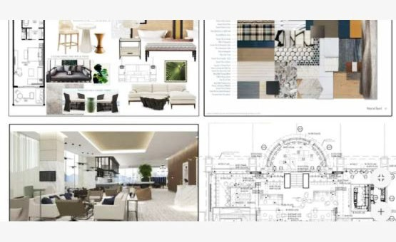

Design development further refines the design presentation, inclusive of ID drawings, tagged floor plans, and final FF&E selections for approval. Photorealistic renderings will be provided for key areas identified during the Concept/ Schematic design phases.

The model room is expected to be installed during this phase and will be reviewed by all stakeholders for approval and subsequently included in the final specifications.

Upon stakeholder approval, drawings will be coordinated with the project architect and FF&E and finish specifications will be submitted to the contractor and procurement agent.

The estimated timeline for this phase is eight (10) weeks. (Some FF&E Items may take longer to manufacture and ship)

**ORGANIZATION AND LOGISTICS OVERSIGHT**



Higney International will manage the RFI process, providing timely clarification to the contractor and relevant consultants.

Throughout this phase, HI will oversee the implementation of the approved design intent and offer value engineering alternatives as needed. The design team will review and approve shop drawings, finish samples, and building materials submittals. Simultaneously, the purchasing process will be underway, with shipping arrangements made to the designated warehouse or Hotel, as directed by the client.

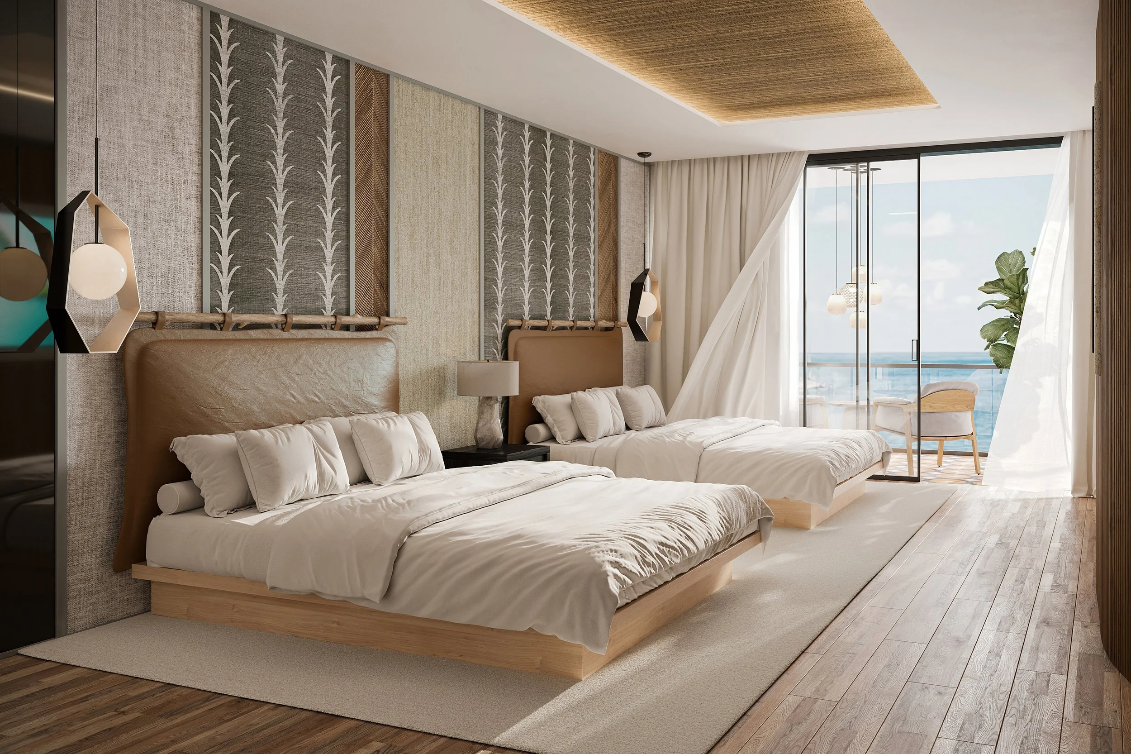

**2**

K E Y P E R S O N N E L

2 KEY PERSONNEL HIGNEY INTERATIONAL & PARTNERS

PETER HIGNEY

EXECUTIVE DIRECTOR

With a deep commitment to hotel development and food & beverage, Peter has spent the past 25 years at the forefront of brand innovation. In key leadership roles—including COO of Nikki Beach and Senior VP of Nikki Beach Resorts Group—he led the creation of standout F&B concepts and later expanded into full-scale hotel design and construction.

Peter’s international experience has sharpened his eye for what resonates in global hospitality, favoring immersive, thoughtful, and well-executed concepts. His work blends visual impact with operational functionality, enabling operators to fully unlock a property's potential.

Having built and operated properties in destinations such as Tuscany, Barbados, Ibiza, Mallorca, Koh Samui, Dubai, and Sardinia, Peter brings a nuanced understanding of the tastes and expectations of discerning global clientele.



ALEXANDRA DRAY

DESIGN OPERATIONS AND PROJECT MANAGEMENT

Alexandra specializes in full-service interior design, purchasing, and project management for hospitality and development projects. Her expertise spans interior architecture, FF&E, OS&E, and OFCI procurement, giving her the ability to manage every phase of a project—from early design consultation through final installation.

She brings extensive experience in hospitality design, supported by a Bachelor of Science in Interior Architecture from the Art Institute and advanced studies in Applied Arts and Art History from MJM Graphic Design School in Rennes, France.

Alexandra’s work blends creativity with technical precision, consistently delivering refined, functional, and beautifully executed spaces tailored to each project’s vision.

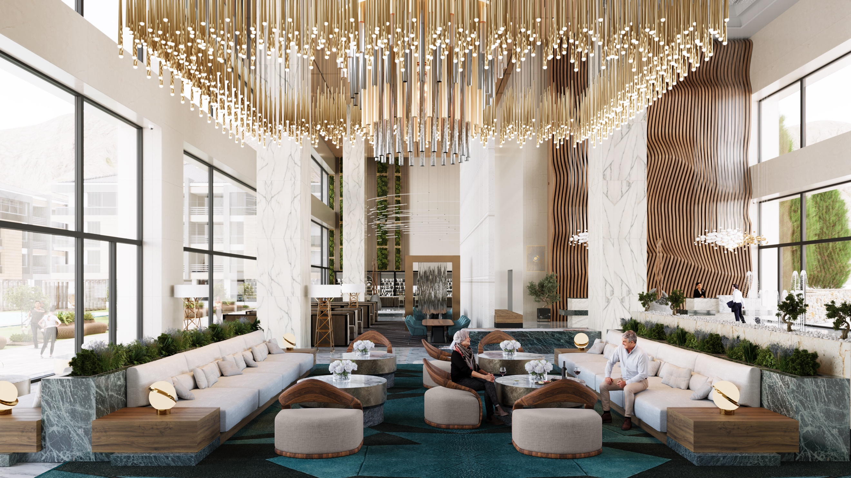

**3**

SCOPE

FEE PROPOSAL

This consulting agreement (this “Agreement”) is entered into as of _______, by and between Chatwal Hotel, New York, New York 130 East 44th Street 10036 (“Client”), and Higney International, a Florida corporation, 1720 Harrison Street, Suite 16A, Hollywood, Florida, (“Consultant”) (each individually a “Party” and collectively the “Parties”) Client intends to design the interior spaces of The Chatwal Hotel (“Property”), which consists of updates to the rooms.

NOW, THEREFORE, in consideration of the foregoing, and other good and valuable consideration, the receipt, sufficiency, and adequacy of which are hereby acknowledged, the Parties, intending to be legally bound, hereby agree the terms and conditions set forth in the attached exhibits.

**Section 1 Phases of Work**

This Project will encompass the following four phases. These phases will be conducted in accordance with a time schedule to be mutually agreed upon by the Parties, which may be modified to accommodate scheduling requirements of any third parties involved in the Project.

Following discussions and meetings with the Client and/or representatives, the Consultant shall prepare and develop design plans, color schemes, materials, decorative FF&E specifications, select furnishings, and coordinate with technical assistance teams as needed to create an integrated design. Consultant shall attend any site or general meetings convened by the Client when such a meeting pertains to the interior design project.

Consultant will have a team on-site as needed documenting the progress vs. existing conditions and verifying that the provided AutoCAD or PDF plans provided by owner's architect and relevant consultants are accurate.

All design phases will adhere to industry standards and local codes to ensure approvals.

1. **Phase I: Scope Analysis:** **Scope of Case Goods Consulting Services:** For the fee of Twelve Thousand Five Hundred Dollars ($12,500), Consultant shall provide Consulting Services for all guestroom types within the Property. These services include, but are not limited to, the following:
   1. **On-Site Review**The consultant shall work with the client to retrieve all relevant data on the room configurations and room types. Consultant shall conduct an on-site assessment of existing guestrooms and relevant areas to evaluate required FF&E, existing conditions, and functional needs. The analysis of FF&E and in-room equipment shall be reviewed for wear and tear, along with resourcefulness, lifespan, and brand cohesion.
   2. **Pricing & Market Analysis**Developing a comprehensive dual pricing strategy for all required FF&E based on quality tiers, materials, manufacturer capabilities, and current market conditions.Identifying and presenting a range of multiple product pricing options and material approaches aligned with the Client’s design intent.
   3. **Value Engineering & Procurement Advisory**Advising the Client regarding cost-saving alternatives, procurement strategies, and value-engineering opportunities. Consultant shall prepare and deliver findings in written and/or digital format, including specifications suitable for the Client’s internal budgeting and approval processes. (The report shall not provide specific models and manufacturers, only estimated costs for the purpose of defining budgetary thresholds) The report shall also provide for shipping estimations, tariffs (if any), and be void of installation fees as requested by ownership.
2. **Phase II: Schematic Design** – Phase II services will consist of the following:
   1. Consultant will incorporate the information from the Client’s plans, photographs, requirements, and recommendations into the development of the architectural plans and specifications selections and schedules.
   2. Consultant will prepare preliminary background colors and materials to include any floor coverings, wall coverings, and paint finishes, soft goods, and upholstered furniture as well as lighting recommendations that will identify the basic concept of the interior design as project scope requires.
   3. The consultant will submit an estimated cost of the interior schemes pertaining to the interior FF&E (Furniture, Finishes & Equipment). The Consultant is not responsible for budgeting anything behind the finished sheet rock or ceiling (e.g., sprinklers, structural, mechanical, electrical, smoke detector systems, etc.).
   4. After approval of Phase III, the Consultant will develop floor finish plans as needed for the areas noted.
   5. The Consultant will prepare the schematic presentation package for presentation to the Client in either hard copy and/or digital format, expressing the design intent for the project.
   6. Phase III is completed upon submission and written approval of the above presentation to the Client.
3. **Phase III: Design Development**

Design Development Includes Specification and Documentation- Desired modifications to the preliminary FF&E and floor plan designs will be performed through the development and refinement of the schemes. Phase III Services will consist of the following:

* 1. Consultant will provide the final design by means of digital presentation boards and final floor plans for all areas.
  2. Consultant will coordinate and prepare finalized professional renderings determined by the Owner and design team for key areas of the project.
  3. Consultant will oversee the Model room development, implementation and model room review.
  4. Client’s contractor or Owner's representative shall prepare an updated budget based on the following information to be provided by the Consultant (if included in the Scope of Work/Services):
     + Concept Electrical, power, data location layout
     + Concept Architectural lighting plan
     + Concept key interior elevations with tags
     + Concept floor finish schedule
     + Coordination with all related sub consultants
  5. Phase III is completed upon submission and written approval of the above presentation.

1. **PHASE IV: FF&E Specification:** A complete, comprehensive, and detailed set of FF&E specifications will be created during Phase III. Such specifications will provide the manufacturer, model or pattern number, color, construction, and quantity. Final ID drawings are fully coordinated with the project architect. The following Phase IV documents will be provided:
   * + Art and artifacts with art keyed on the elevations as called for
     + Carpet and wallcovering installation plans as required
     + Decorative lighting FF&E specifications
     + FF&E Specifications books

**DI.** Consultant will provide complete FF&E specifications books describing and illustrating all materials, fabrics, color schemes, detailed drawings or manufacturer’s catalog cut sheets of all furniture, itemized furnishings and equipment, cross-reference to drawings and FF&E specifications.

**DII.** The consultant will provide FF&E quantities and FF&E specification and BOQ

**DIII.** Consultant will provide full FF&E specifications and all RFQ documentation necessary to purchase the job. Client is responsible for bidding all or any construction, and installation costs and handling all project management and contracting of subcontractors.

**DIV.** Phase IV is complete upon submission of the FF&E electronic specification books and one hard copy spec book to the Client and written approval of such FF&E specifications.

1. **Phase V:** **Procurement and Construction Administration**   
   Requests for Information: Periodic visits to the project site to review that work is being performed in accordance with the Consultant’s documents, FF&E Specifications, and design concepts.

Phase V Services will consist of the following:

* 1. Consultant will review and approve all FF&E samples to ensure compliance with design drawings and FF&E specifications.
  2. Consultant will review submittals and sign all millwork shop drawings as part of the Services.
  3. During all phases, the Consultant shall make no less than a minimum of three (3) visits to the site. All expenses for travel are reimbursable to the consultant.
  4. Consultant will order all FF&E approved by Client upon receipt of funds.
  5. Phase IV is completed upon completion of the final punch list.

1. Consultant will not have control over or be in charge of and is not responsible for: (i) the means, methods, techniques, sequences or procedure of construction, fabrication, for safety precautions and program in connection with the work; (ii) the acts or omissions of the contractors, subcontractors, suppliers; (iii) any other persons performing any of the work; or (iv) the failure of any third party to carry out the work or to meet their schedules for delivery or completion in accordance with the contract documents.
2. Consultant will endeavor to guard the Client and operator against defects and deficiencies in the work of the contractor and, in doing so, reserves the right and authority to recommend that the client’s representative condemn or stop any work that, within Consultant’s beliefs is necessary for the proper performance or quality standards of this Agreement.
3. **Purchase of Furniture and Fixtures:** 
   1. **Budget Submission:** The Consultant shall develop and present a detailed budget for the purchase of furniture and fixtures for the Client's review and approval.
   2. **Estimates from Manufacturers:** The Consultant will obtain and provide the Client with written estimates from each manufacturer for the selected furniture and fixtures. The Client must approve these estimates before any funds are disbursed.
   3. **Fund Transfer:** Upon receiving the Client’s approval of the budget, the Client shall transfer the approved funds to the Consultant. These funds will be held in a dedicated Trust account, established specifically for this purpose.
   4. **Payment Process:** Once the estimates are approved, the Consultant will facilitate the payment directly to the manufacturer from the Trust account.
   5. **Account Statements:** The Consultant shall provide the Client with monthly account statements that reconcile all transactions within the Trust account. This will include details of expenditures, remaining balances, and any other pertinent financial information. Upon completion of the project, Consultant shall provide reconciled transfer and payment records.
   6. **Return of Unused Funds:** At the termination of this contract, any unspent funds remaining in the Trust account shall be returned to the Client promptly.
   7. **Additional Funding Requests:** In the event that additional funds are required beyond the approved budget, the Consultant must submit a requisition for approval by the Client. No additional funds shall be transferred to the Trust account without the Client's prior written consent.
   8. **Tariffs:** Consultant is not responsible for any tariffs that may come into effect during the purchasing phase and the client shall be responsible for any tariff that is imposed or modified during the purchasing cycle.
   9. **Change orders and Returns:** In the event an item is returned to the manufacturer, or the Client chooses a different path after an order has been placed, the client acknowledges that the manufacturer may charge a restocking fee and return shipping fees, and agrees to pay the associated expenses should it become required.
   10. **Insurance:** The consultant shall provide the client with product shipping insurance options and bond fee options. Client shall be responsible for such payments directly to providers, and Client hereby waives any and all obligations by Consultant to obtain shipping insurance on behalf of Client.
   11. **Permits:** The consultant is not responsible for obtaining permits. Should a permit be required, the client shall take all necessary steps to procure such permits for work to continue as needed to complete the project.

**Section 1 Full Scope of Services**

1. The Consultant shall cooperate and work in accordance with the Client, Client’s other project support, Consultants, Client’s Sub-Consultants and Client’s Representative (collectively “The Technical Assistance Team”). The full Scope of Services is attached as **Exhibit A** and incorporated by reference.
2. In working with the Owner’s AutoCAD or PDF plans for the Project, Consultant will create conceptual schematic designs for all areas included in the services. Consultant will provide one
   1. Schematic version of the design and two (2) redline changes initiated by the Client to the final plan. Once Client has approved the entire budget proposal, Consultant will present the design of the areas as listed in the Services to the Client.
   2. Additional professional full color photorealistic renderings are available for a fee if requested. Consultant will design all the floor plans, finishes, and FF&E to support the feel of the Project. Consultant will specify all furniture and furnishings (i.e., sofas, chairs, case goods, decorative lighting, area rugs, window treatments, upholstery, art, and accessories).
3. The scope of services to be provided by the Consultant is as follows and to the extent required by industry standards and local code.
   1. Consultant shall provide an electronic FF&E specification manual as requested and one construction materials manual as needed for all areas included in this Scope of Services. The FF&E specification documents shall provide documentation for all items selected, which shall include photos, finishes, and materials of all specified items as well as color story card indicating the fabrics/finishes used in each area.
   2. Consultant will provide digital finish presentation boards.

**Section 2 Compensation, Additional Services**

1. **Design Fees:** Consultant is entitled to a total payment of **One Hundred Twenty Five Thousand ($125,000)** to be rendered. The compensation will be paid to the Consultant in the following manner:
   1. **Scope Analysis Fee:** Upon execution of this Agreement, the Client shall pay a fee of Twelve Thousand Five Hundred Dollars ($12,500) for the Scope Analysis Consulting Services (“Scope Consulting Fee”). This fee covers the scope of work described in the Phase I: Scope Analysis Services section of this Agreement and is non-refundable. The Scope Analysis Consulting Fee represents the minimum amount payable under this Agreement, regardless of whether the Client elects to proceed with the remaining phases of the full Design Services package.

All approved travel required to perform the Scope Analysis Consulting Services—including airfare, lodging, meals, ground transportation, and related costs—shall be subject to client approval and billed to the Client as reimbursable expenses.

* 1. **Full Design Services Fee Structure:** The Scope of Work Consulting Services, the remaining balance of the Design Fee shall be due at the completion of each phase as follows:

|  |  |
| --- | --- |
| Phase I: Scope Analysis | $12,500 |
| Phase II: Schematics Design | $35,000 |
| Phase III: Design Development – Specification & Documentation | $45,000 |
| Phase IV: Specification & Documentation | $32,500 |
| Phase V: Procurement & Construction Administration (Commission) |  |
| Total | $125,000 |

1. **FF&E Commission Terms:** Higney International shall receive a commission payment of eight percent 5% of all items purchased under the FF &E and OS&E package for the project. The commission shall be payable by the client, and payments shall be due no more than 15 days after orders are approved and paid to the vendor.
2. **Fees for Additional Services**: If the Client requires services that are additional to those referred to herein and only insofar as Client approved such additional services, the Client will pay for such Additional Services in accordance with the following schedule:

|  |  |
| --- | --- |
| Principal | $200/hr |
| Director | $175/hr |
| Sr. Architect / Sr. Designer | $140/hr |
| Interior Designer | $80/hr |

**Section 3 Compensation, Additional Services**

1. All **FF&E** deliveries are provided **exclusively on a curb-side basis** to the warehouse or facility designated by the client. **Any services involving the movement, installation, or placement of FF&E inside the property are expressly excluded from this agreement** and will require a **separate quotation and written approval** as additional billable work.
2. **Rendering services:** The project submission includes hours at approximately twelve (12) hours per rendering for design development and coordination. For each rendering, consultant will provide three (3) rounds of comments and review if additional changes to the renderings are needed. Additional professional photorealistic renderings if requested, will be billed at a cost.

**Section 4 Limitation of Services**

**No Architectural or Engineering Services**

Consultant does not provide architectural, structural, mechanical, electrical, plumbing, fire-life-safety, or engineering services. All drawings, plans, lighting layouts, and elevations prepared by Consultant are for **design intent only**. Client shall retain licensed professionals to provide all architectural and engineering services required for permitting, code compliance, and construction.

**Permits and Approvals**

Consultant shall not obtain permits or approvals from any Authority Having Jurisdiction. Client is solely responsible for securing all required permits and approvals. Consultant shall not be responsible for delays or costs associated with permitting or regulatory review.

**Construction Means and Methods**

Consultant shall not control or be responsible for construction means, methods, sequencing, safety programs, or the acts or omissions of contractors, subcontractors, suppliers, or labor forces.

**Union Labor**

Consultant shall not directly supervise, direct, or communicate work instructions to union labor. All interaction with union personnel shall occur exclusively through the Client’s contractor, construction manager, or designated representative. Consultant shall not be responsible for jurisdictional disputes, grievances, work stoppages, or labor-related claims.

**Procurement & Trust Account**

Upon Client approval, FF&E funds shall be deposited into a dedicated trust account for payment directly to manufacturers. Consultant acts solely as a payment facilitator and is not the seller of record. Title to FF&E transfers directly from manufacturer to Client. Consultant is not responsible for manufacturer delays, defects, insolvency, or shipping disruptions.

Any unused funds shall be returned to Client upon project completion or termination.

**Section 5 Termination**

This Agreement may be terminated by the Client by giving the Consultant written notice of termination by certified mail, return receipt requested, addressed to the Consultant at its address set forth on the first page of this Agreement. Any such notice of termination shall be effective on the 30th day after the date of its delivery to the Consultant (“Effective Date”), provided that any such termination shall not affect the right of the Consultant to recover fees and expenses incurred by it in performing this Agreement prior to Effective Date. Upon payment by the Client of all such fees and expenses, all written specifications, plans and other work product created as of the Effective Date by the Consultant pursuant to this Agreement shall be provided by the Consultant to the Client and shall be the property of the Client and may be used by it freely, without restriction or limitation.

**Section 6 Dispute Resolution and Governing Law**

This Agreement shall be construed and governed by the laws of the State of Florida, without giving effect to any choice or conflict of law provision or rule.

If a dispute arises from or relates to this Agreement or the breach thereof, and if the dispute cannot be settled through direct discussions, the parties agree to endeavor first to settle the dispute by mediation administered by the American Arbitration Association under its Commercial Mediation Procedures before resorting to arbitration.

The parties further agree that any unresolved controversy or claim arising out of or relating to this Agreement, or breach thereof, shall be settled by arbitration administered by the American Arbitration Association in accordance with its Commercial Arbitration Rules and judgment on the award rendered by the arbitrator may be entered in any court having jurisdiction thereof. Claims shall be heard by a single arbitrator. The arbitrator will have no authority to award punitive damages, or any other damages not measured by the prevailing party's actual damages, except as may be required by statute. The arbitrator shall not award consequential damages in any arbitration initiated under this section. Pursuant to the Commercial Arbitration Rules, the arbitrator will have the authority to allocate the costs of the arbitration process between the parties but shall not have the authority to allocate attorneys' fees to either party.

**IN WITNESS THEREOF**, the parties have set their hands and seals hereto the date and year indicated below.

**CLIENT**

Chatwal Hotel

By: _________________________ Date: ________________

Name:

Title:

**CONSULTANT**

Higney International

By: _________________________ Date: ________________

Peter Higney

Executive Director

**PAGE LEFT INTENTIONALLY BLANK**

**EXHIBIT A**

| **Area** | **Requirement** | **Questions** | **Responses** |
| --- | --- | --- | --- |
| **Corridors** | |  |  |
|  | Replace Carpeting |  |  |
|  | Revisit Wall Finishes for potential change to match carpeting |  |  |
|  | New Artwork? | Confirmation of black and white artwork - reuse existing or propose new? | Explore new artwork options  Recommend an art consultant. |
|  |  |  |  |
| **All Rooms** | |  |  |
|  | Remove Upholstered Chair | Remove permanently or replace with another seating type? | Remove |
|  | Permanently Fix Desk Hutch to make inoperable | Remove hutches to another location, people on site to do work, recover hutches? | Replace 15-20% where they act as desk, other rooms - shut them, and make like a credenza as a decorative piece with the closet (see detailed room requirements below). |
|  | Remove Desk Chair and replace with Ottoman under desk |  | Rooms with desks nailed shut, plan to remove jetson lounger and replace with soft seating (club chair 27”/30" table to act as desk/work station. |
|  | Drapery | Full replacement or reuse hardware? Sheer + blackout or blackout only? | Lighter drapery. |
|  | Entry Hallway to be reimagined - lighter color scheme |  | Ceiling currently dark brown. Some kind of solution for banged up walls from luggage - concern is too many finishes in the room. Not a very high priority from a budgetary perspective. |
|  | New Nightstands with power connectivity |  |  |
|  | Replace Desk Lampshade | Replace whole lamp? | Only lamp shade |
|  | Headboards: remove decorative sheet or replace with monogrammed/designed sheet | Cost of union workers vs. replacing headboard/base entirely | Change headboard only, currently a sheet over the back changed with each guest. |
|  | Flooring replacement | Do you want carpet and wood refinished? | 20 rooms - carpet is destroyed and replace with LVT wood - won't be rolled out at the gate. **To be specified to be rolled out later. Area rug - TBD.**   6-8 existing rooms with wood are currently being refinished. Have an area rug and to be replaced. |
|  | Review Terrace for potential replacements | FFE replacements, flooring options | Idea to do a survey and see what should/should not stay. |
|  | New Artwork? | Confirmation of black and white artwork - reuse existing or propose new? |  |
|  |  |  |  |
| **2nd Floor** | |  |  |
| 204, 205, 206 | |  |  |
|  | Remove Chair |  |  |
|  | Add Table and Club Chairs |  |  |
|  | Replace Sofa where existing |  |  |
|  |  |  |  |
| **3rd - 6th Floors** | |  |  |
| X01, X03 (8x Rooms) | |  |  |
|  | Replace Desk and Chair with new credenzs |  |  |
|  | Add club chair/table |  |  |
|  | Review Storage requirements in room |  |  |
|  | Change to King Bed |  |  |
|  |  |  |  |
| X02 (4x Rooms) | |  |  |
|  | Replace Desk and Chair with new credenzs |  |  |
|  | Add club chair/table |  |  |
|  | Review Storage requirements in room |  |  |
|  |  |  |  |
| X04, X05, X10, X11, X12 | |  |  |
|  | Add club chair(s) /table |  |  |
|  |  |  |  |
| X06 |  |  |  |
|  | Change to Double Queen |  |  |
|  | Add club chair(s) /table |  |  |
| X07 |  |  |  |
|  | Replace Lounger with Pull out Couch |  |  |
|  | Add club chair(s) /table |  |  |
|  |  |  |  |
| X08, 409, 509, 609 | |  |  |
|  | Replace Lounger with Pull out Couch |  |  |
|  | Add club chair(s) /table |  |  |
|  |  |  |  |
| 511, 611 |  |  |  |
|  | Change to DQ - |  |  |
|  | Required FFE Changes |  |  |
|  |  |  |  |
| 309 |  |  |  |
|  | Outsider Suite - GYM? | What does this mean? | Room theme currently based on Broadway musical, art work, etc..  **Room will have to be brought into spec with rest of the hotel - TBD** |
|  |  |  |  |
| **7th -9th Floors** | |  |  |
| X01, X07 |  |  |  |
|  | Remove Chair |  |  |
|  | Add Club Chair(s) / Table |  |  |
|  | Demo Kitchenette |  | Cooktop, mini sink - put in a few rooms for COVID. Will need to provide specs for what to put in there. |
|  |  |  |  |
| X02 |  |  |  |
|  | Rethink seating |  |  |
|  | Demo Kitchenette |  |  |
|  |  |  |  |
| X03, X04, X05 | |  |  |
|  | Remove Chair |  |  |
|  | Potential new standalone desk |  |  |
|  |  |  |  |
| X06, X09 |  |  |  |
|  | New pull out couch |  |  |
|  | Add Club Chair(s) / Table |  |  |
|  | Potential new standalone desk |  |  |
|  |  |  |  |
| 708, 808, 908 | |  |  |
|  | Owner will swap out Murphy |  |  |
|  | ID to redesign loose FFE in room, seating and tables |  |  |
|  |  |  |  |
| 601, 603 |  |  |  |
|  | Change to King |  |  |
|  |  |  |  |
| 606, 807, 611 | |  |  |
|  | Change to DQ |  |  |
|  |  |  |  |
| 907 |  |  |  |
|  | Change to King Bed |  |  |
|  |  |  |  |
| **10th Floor** | |  |  |
|  | Provide Alternate for 2x Specialty Suites - Full Renovation |  | Bid as separate quotation |
|  |  |  |  |
|  |  |  |  |
| **OTHER QUESTIONS** | |  |  |
|  |  | Do you want to change the bathrooms to match the new bedroom design? | Yes keep bathroom as is |
|  |  |  | 3-4 color schemes in the hotel |
|  |  |  | **There are ADA rooms - specs TBD.** |
|  |  |  | Wall covering staying  Leathered upholstered closets staying  Carpets to change on an as needed basis |
|  |  |  |  |